What will we be learning?  Paper 2  Section 3 – Socio-cultural influences | Why this? Why now?  GCSE PHYSICAL EDUCATION  SECTION 3 (PAPER 2)  This unit is taught in Year 11 for paper 2.  You will develop your knowledge and understanding of the factors that continue to impact on physical activities and sports in the UK today. You will be introduced to engagement patterns of different social groups in physical activities and sports. You will develop your understanding of the influences of commercialism and the media on physical activities and sports. You will develop your understanding of sportsmanship, gamesmanship and deviance in sport along with being able to apply theories to practical examples from physical activities and sports. | Key Words:  Sport  Sport England  Moderate activity  Participation rates  Recreation  Disability  Long term health conditions  Rooney Rule  Commercialisation  Sportsmanship  Etiquette  Gamesmanship  Deviance  Body Dysmorphia
What will we learn?
Section 3 – Socio-cultural influences
3.1 Engagement patterns of different social groups in physical activities and sports
- Physical activity and sport in the UK
- Participation in physical activity and sport
3.2 Commercialisation of physical activity and sport
- Commercialisation of sport
3.3 Ethical and socio-cultural issues in physical activity and sport
- Ethics in sport
- Drugs in sport
- Violence in sport
What opportunities are there for wider study?
Sixth form studies
- Cam Tech Sport
- A level PE
Careers/degree courses
- Sports science
- Physiotherapy
- PE teacher
How will I be assessed?
- Paper 2 (worth 30%) – 60 marks – 60 minutes
- AEP Written coursework

3.1 ENGAGEMENT PATTERNS OF DIFFERENT SOCIAL GROUPS IN PHYSICAL ACTIVITIES AND SPORTS  Physical activity and sport in the UK  - Be familiar with current trends in participation:  - Using different sources (Sport England, NGBs, Department of Culture Media and Sport (DCMS))  - Of different social groups  - In different physical activities and sports  Participation in physical activity and sport  - Understand how different factors can affect participation, including: age, gender, ethnicity, religion/culture, family, education, time/work commitments, cost/disposable income, disability, opportunity/access, discrimination, environment/climate, media coverage, and role models.  - Understand strategies which can be used to improve participation: promotion, provision and access.  - Be able to apply examples from physical activity/sport to participation issues. | 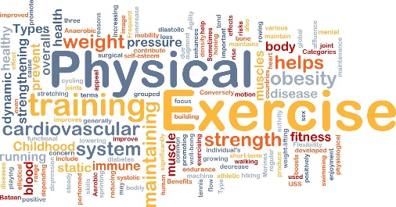
3.2 COMMERCIALISATION OF PHYSICAL ACTIVITY AND SPORT  Commercialisation of sport  - Understand the influence of the media on the commercialisation of physical activity and sport: different types of media (social, internet, TV/visual, newspapers/magazine).  - Know the meaning of commercialisation, including sport, sponsorship, and the media (the golden triangle): positive and negative effects of the media on commercialisation, and be able to apply practical examples to these issues.  - understand the influence of sponsorship on the commercialisation of physical activity and sport: positive and negative effects of sponsorship on commercialisation and be able to apply practical examples to the issue of sponsorship. | 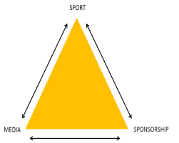
3.3 ETHICAL AND SOCIO-CULTURAL ISSUES IN PHYSICAL ACTIVITY AND SPORT  Ethics in sport  - Know and understand the value of sportsmanship, and the reasons for gamesmanship and deviance in sport, as well as apply them to practical examples.  Drugs in sport  - Know and understand the reasons why sports performers use drugs.  - Know the types of drugs and their effect on performance: anabolic steroids, beta blockers, and stimulants.  - Give practical examples of the use of these drugs in sport.  - Know and understand the impact of drug use in sport: on performers and on sport itself.  Violence in sport  - Know and understand the reasons for player violence and give examples of violence in sport. | 